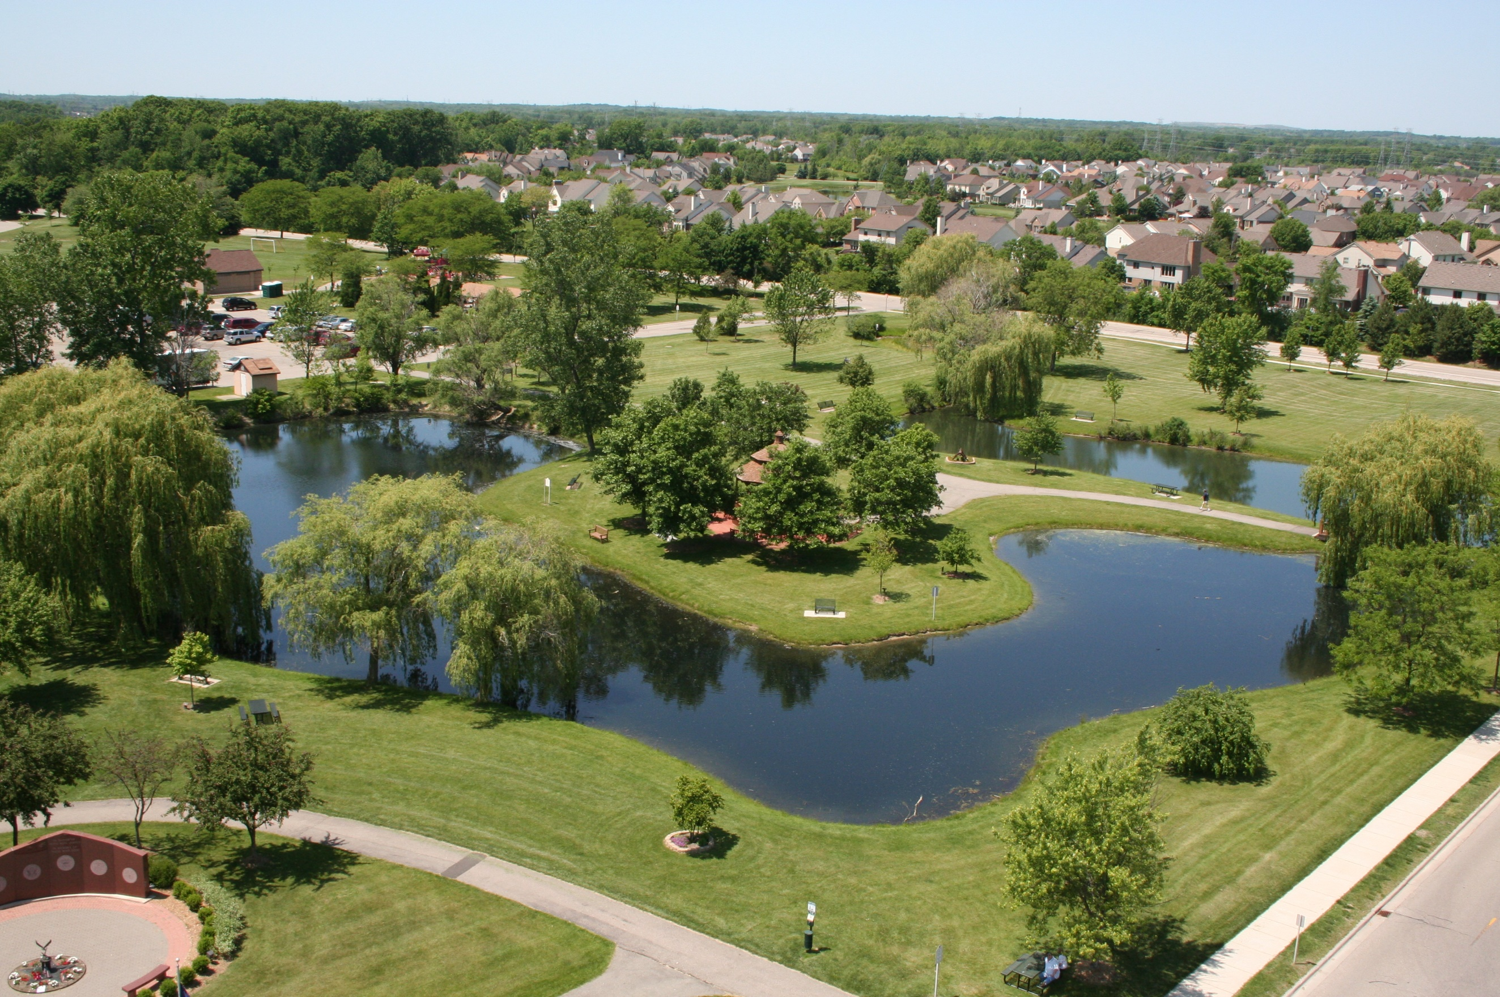
Planning for Urban Forestry
A guide for municipalities

COMPILED BY: Megan McLaughlin
CREATED: July 2023


Getting Started
At an increasing rate, cities across the country are realizing the value that urban forestry brings to the health and well-being of residents and the local landscape.
There is a growing need to manage public and private trees, and long-term planning is required to help reach desired outcomes and strengthen common understanding of municipal goals and priorities. Planning is the process of defining future actions to meet desired goals in a strategic and thoughtful manner.
This workbook is designed to support urban forestry planning efforts by documenting the steps and considerations needed to develop an effective, long-term forestry plan. This workbook is a fillable planning tool that provides best practice considerations and outlines data and information that typically funnels into a comprehensive plan.
Completing this workbook, the user will navigate through the following phases:

How to use this workbook
Begin by reviewing the workbook overview on the next page to better understand what information will be collected and kick-start additional considerations that may be relevant to your planning process. Each section provides questions and resources to guide the user through common considerations. These are strictly guiding questions, and there may be more considerations needed or questions answered on a community-by-community basis. Use the spaces provided to document your community’s efforts. The text in grey is meant as a placeholder and to be removed. By completing this workbook, your community will have built the foundation for your urban forestry master plan (UFMP).

*This material is based upon work supported by the Department of Energy and the Michigan Department of Environment, Great Lakes, and Energy under Award Number EE00008653 as part of the Catalyst Communities program. Find this document and more about the CLC Fellowship that supported this project at graham.umich.edu/clcf.

Workbook overview
Here are the components of each phase and suggested time considerations to support work plan planning.

Planning to Plan

Assemble the planning committee
The first step is to assemble an urban forestry planning committee. Consider the interest, expertise, and time availability of potential committee members and which perspectives and voices should have a say in the UFMP. This team could include voices from:
- Department of Public Works
- Downtown Development Authority
- Parks & Recreation Department
- Planning Commission
- Master Planning Advisory Committee
- Township Board
- Local Forestry Organizations
Collaborator Name | Group (where are they joining from) | Role (developing, implementing, informing, affected by)
Stacey Johnson | DDA | Informing
Bill Blossom | Planning Commission | Developing
Pam Silver | Attorney | Informing

Purpose statement
Planning consists of identifying the purpose and scope of the UFMP. The purpose should resonate with those who will be utilizing the plan, those funding its development and implementation, and the community members who will ultimately benefit from the plan.
To clarify the purpose, explore:
- Are there specific concerns/practices that need to be addressed?
- Are urban forestry benefits being threatened?
- Are there community-specific challenges that need to be addressed, such as emergency planning or pest control?
- Are funds available? Are funds being used appropriately?
Articulate the purpose statement here…

Work plan development
A work plan outlining key milestones and goals in each planning phase is useful to keep momentum when developing the UFMP. Below is a work plan task table that can be used to highlight key activities that need to be accomplished, a target date for completion, and who will lead the progression of the task. This timeline will cover the planning and development phase for the long-term forestry plan.
Task Description | Target Date | Lead
Pre-Planning
Assemble forestry committee | 5/7/24 | John C.
- Send interest survey to departments
Begin work plan development
Gather information and assign roles
Assessment Phase
Strategic Planning Phase
Development Phase

RECOMMENDED RESOURCES
Title | Section | Summary
Build a Stakeholder Coalition | Planning Committee | Successfully weave together different perspectives of collaborators and anchor your efforts with a strong group of advocates.

Assessment Phase

History
Providing a history of the community’s urban forestry to date will help explain the current state of forestry in the area.
- How has site history affected the development and composition of the current urban forest?
- Is there a history of community stewardship of trees?
- Are there trees of historical or cultural significance that are important to protect?
- Has a land-use change analysis been conducted?
- Has there been a budget for urban forestry?
Describe your urban forest history here…

Environmental assessment
Environmental factors can have an impact on the urban forest and should be considered during planning to avoid preventable damage.
- What environmental factors (frequent flooding, heat island) are relevant to your community that may require special considerations when making management decisions?
- How can these factors be considered in the urban forest master plan?
Enter your environmental assessment information here…

Tree inventory
An inventory of public trees is important in planning for and making effective forestry management decisions including budget strategies and priority areas.
- Does a tree inventory need to be completed?
- What is the current composition and distribution of the public trees?
- What is the current condition of public trees?
- What role will the inventory play in the urban forestry plan?
- What inventory method have/will you use?
- Is there adequate species and age diversity within the urban forest?
Enter your tree inventory responses here…

Canopy cover assessment
Canopy cover assessment provides a measure of a community’s tree canopy cover as a percentage of the total land area to serve as a baseline for setting tree canopy goals and measuring progress.
- What percentage of the geographic region is covered by trees?
- Where is management needed to sustain current canopy levels?
- What ecological services does the canopy cover currently provide?
- How does canopy coverage range from industrial, commercial, and residential areas?
- Are there tree equity concerns in any regions of the area?
Enter your canopy cover response here…

Management responsibilities
Urban forestry responsibilities can be complex. Responsibility may not always fall on a department but rather an individual or multiple individuals.
- How are activities of different entities coordinated and monitored?
- Are the various entities that affect trees working with the same vision?
- Which entities regulate or affect segments of the urban forest?
- Who educates the public about urban forest and tree care regarding both private and public property?
- Which entities perform activities that affect the urban forest?
- Which departments have direct tree care responsibilities, and what portions of the urban forest do they manage?
- Are there adequate staff, training, and budget to provide for tree care needs?
Enter your management responsibility responses here…

Management practices
Sustaining an urban forest requires active management, and past practices explain current management strategies.
- Are best practices employed for the sustainable management of urban forests?
- Does a practice standards manual exist?
- Are standards and practices up-to-date based on the best available information and research?
- How are trees maintained, and what is the duration of the maintenance cycle?
- When each tree has reached the end of its useful lifespan, is biomass reused and at its “highest and best use”?
- How are decisions made relative to tree selection, placement, maintenance, and removal?
- Is there adequate equipment considering condition, maintenance, and expected service life?
- Are most of the pruning and removals on a scheduled or unscheduled basis, such as response to calls or weather events?
- Is there adequate budget and funding to achieve sustainable urban forest management?
Enter your management practice responses here…

Plans
Plan considerations are important because additional planning strategies can reinforce urban forestry goals.
- Are there urban forestry components in other plans?
- Which documents (city codes, general plan, specific plans, design guidelines) include tree-related guidelines and regulations?
- What will be the relationship of the UFMP to other planning documents?
Enter your plans responses here…

Policies
Policies that affect urban forestry can be incorporated into city government practices and can outline the management of urban forests directly.
- Are there tree-related policies?
- Are tree-related policies current?
- Are policies followed?
Enter your policy responses here…

Regulations
It may be important based on your community’s urban forestry practices to secure protections relating to tree activities.
- Are there any regulatory measures pertaining to parts of the urban forest?
- Which areas or classes of trees are subject to regulations?
- How does regulation impact management?
- Are there any tree ordinances?
- What is the impact of existing regulations on targeted tree populations?
- To what degree are regulations/ordinances enforced?
- Do ordinances need evaluation or revision?
- Do state or federal regulations need consideration regarding management of the urban forest?
Enter your regulations responses here…

Community
Assess your community’s opinions regarding potential changes due to the UFMP.
- Who are the key people and groups that are impacted by this plan?
- What is the level of awareness and interest among community residents and officials?
- Are there people and/or groups whose support you will need?
- Who might be good at helping to develop or review the plan?
- Which stakeholder groups are likely to influence the success of the plan?
- Are these people aware of urban forestry, community concerns, and the specific needs of the area to be planned? If not, how will these groups be educated and engaged?
Enter your community responses here…

Other circumstances
- What are the economic and political realities in your community/municipality?
Enter any circumstantial information here…

RECOMMENDED RESOURCES
Title | Section | Summary
Rapid Risk Assessment | Environmental Assessment | Understand environmental factors your community faces and how trees can mediate impacts.
Hardiness Zone Lookup | Environmental Assessment | Look up your communities hardiness zone to learn what trees are expected to thrive in your areas temperature extremes.
Forest Service Climate Tools and Data | Environmental Assessment | A gallery of climate maps, tools and resources supporting environment analyses.
National Stormwater Calculator | Environmental Assessment | EPA tool that estimates the annual amount of rainwater and frequency of runoff from a specific site.
USDA Web Soil Survey | Environmental Assessment | Access relevant soil and related information needed to make land-use and management decisions.
How to Conduct a Street Tree Inventory | Tree Inventory | Learn the basics needed to conduct a useful tree inventory.
i-Tree | Tree Inventory/Canopy Cover | Free tool and support for estimating tree benefits in your area.
Urban Tree Canopy (UTC) Assessment | Canopy Cover | This report provides an overview of the approaches, methods, and data sources used in UTC assessments.
A guide for assessing urban forestry | Canopy Cover | A guide for quantifying urban forest services and management for future generations.
Great Survey Questions | Community | A how-to on writing survey questionnaires and common errors to avoid.

Strategic Planning Phase
Based on the assessment phase, some planning needs may have become evident. Here you will take what you know about your community and develop goals, objectives, and actions. Organize data to consider the needs related to the urban forest. What issues and trends can you identify related to the following?

Visioning
Vision statements ensure that developers of a plan have a common understanding about the outcome and include elements that describe both the urban forest itself and how it is valued by those who manage it.
- What is the community’s vision for the urban forest?
- How will the area be different because of the plan?
- How will the community benefit from the plan?
Enter your visioning statement here…

Scope
Scoping focuses on addressing specific information gaps that need to be filled to inform and catalyze action towards your end goal.
The scope will address in a concise manner:
- Who will be responsible for plan development?
- What geographic area will the UFMP cover?
- What information is needed?
- What timeframe will the UFMP address?
- What will the end result be?
Articulate your scope here…

Vegetation needs
- What are the needs related to tree resources themselves?
- What processes are needed to maintain the forest?
- How can you achieve appropriate tree cover community wide?
- How can planning address age distribution and diversity of trees?
- Where are trees needed to meet equitable distribution?
- What practices would need to be continued or changed to maintain or expand the existing urban forest?
Enter your vegetation needs here…

Management needs
- What management actions would be needed to reach target canopy levels?
- Who will need to be involved with short-term and long-term care and maintenance?
- How can you improve the ability to schedule and track projects and maintenance?
- How will you address coordination between departments with respect to tree issues?
- Will municipal ordinances be changed or created to better address trees?
- Are there alternative or stable funding sources for trees?
- Will a tree board be created?
- Could efficiency be improved in any way?
Enter your management needs here…

Community needs
- Is awareness and education needed regarding urban forest benefits, management, and tree care?
- How will the public perceive and interact with the urban forest?
- Can guidelines be shared to promote protection of existing trees?
- Is there proper enforcement of tree ordinances?
- Are there programs to improve tree care in commercial landscapes?
- Who are the licensed tree care contractors and are community members aware of their tree care responsibilities?
Enter your community needs here…

Goal setting
Goals are statements that relay the general outcome you wish to achieve. Strategies are even more specific and break goals into different components for action. The action step(s) is what needs to be done to achieve the outcome.

Justification
It is considered best practice to include planning justification, especially if intended plans call for substantial budget increases.
- How will these goals and strategies improve urban forestry practices?
- Will implementation of these goals improve public safety?
- Is this plan cost-effective? What problems will be solved or reduced?
- Were there any alternative options considered, and why were they rejected?
- Are there any consequences of not implementing these plans?
Enter your justification response here…

Implementation
Describe how proposed actions will be carried out to meet your stated goals.
Goal #1: Become a Tree City USA
Strategy 1.1: Create and maintain a tree board
Action | Cost/Funding Source | Performed by | Completion Date | Priority Level
1.1.1: Begin outreach to potential collaborators | $$ | City Official | xx/xx | High
1.1.2:
Strategy 1.2: Develop a Tree Ordinance
Goal #2:

Budget
- What does the municipality need, and what can it afford in terms of planting, maintenance, and removal?
- Have you investigated all possible sources of funding for the plan?
- Are there available grants or other funding opportunities available?
- How will you develop and present the budget?
- Upon which scenario should the budget be based? How will the budget be allocated on an annual basis?
Enter your budget plans here…

Monitoring
- How will you assess whether implemented strategies are moving you toward reaching your goals?
- Which trees or activities need to be monitored?
- What additional factors need to be monitored?
- Will you be monitoring the entire population or a sample?
- Will data be collected continuously or at specific intervals?
- Do some data need to be collected in a specific season or time of year?
- How frequently will you do data summary and analysis?
- Who will collect, analyze, and use the information?
- How much staff time will be needed?
- How and where will the data be stored?
Enter your monitoring plans here…

Strategy | Monitoring Plan for Actions
1.1 | 1.  2.

RECOMMENDED RESOURCES
Title | Section | Summary
Visioning | Visioning | A guide for a collaborative, creative practices that leads to a shared community vision and common values.
Ordinances Best Practices | Regulations | Introduction to the myriad of regulatory tools available to assist in the proactive management of the urban forest.
Making Your Community Forest-Friendly | Regulations | A worksheet designed to help communities review and revise regulations to conserve and protect valuable trees and encourage new plantings.
Set Effective Tree Canopy Goals | Goal Setting | Learn how to set a UTC goal that is both empirical and ambitious.
The Value of Green Infrastructure | Justification | A guide to recognizing economic, environmental, and social benefits of urban forestry.
Budget Templates | Budget | Worksheets used to estimate budget figures for tree care.
Urban Forest Funding | Budget | Learn about urban forestry funding support available.
SFI Urban and Community Forest Sustainability Standard | Monitoring | Review effective standards for increasing engagement and improving performance of urban forests.

Development Phase

Compile the plan
Here you will organize the information you’ve gathered from the assessment and strategic planning phases and organize your UFMP. The plan should mainly include the following sections:
- Executive summary
  - Summary of master plan
- Introduction
  - Statement of purpose and scope
  - Vision
  - History
- Current Status of Urban Forest
  - Inventory and environmental assessment summaries
    - Environmental assessment
    - Tree inventory
    - Canopy cover assessment
  - Administrative and community assessment summaries
    - Management responsibilities and practices
    - Plans, policies, and regulations
    - Community
- Goals and implementation plan
  - Goal setting
  - Implementation
- Budget justification
  - Justification
  - Budget
- Monitoring plan
  - Monitoring
- Appendices
  - Include detailed references, resources, inventories, ordinances, budgets, maps, plans, and document that which may change.

Plan review
- How will you get stakeholder and community feedback on the draft plan?
- How will you organize stakeholder comments?
- How will final decisions be made among the committee?
- How many iterations of the plan will be allowed?
Enter your plan review responses here…

Plan approval
- Are decision makers already aware of the plan prior to request for approval?
- Are there any barriers to gaining approval for this plan?
Enter your plan approval responses here…

Monitor Phase
Following the adoption and implementation of the UFMP, you will begin moving forward with your monitoring plan.

Evaluate
- Who will you implement your monitoring strategy?
- How will you track progress toward reaching your goals?
- Is there a method of reporting findings to the planning committee?
Enter your evaluation plans here…

Take corrective action
- How will you adjust your plan following analysis of monitoring data?
- How long will it take for changes to be made to the plan?
Enter how you will take corrective actions here…

RECOMMENDED RESOURCES
Title | Section | Summary
Evaluation of urban forestry | Evaluate | Evaluation methods for formulating and monitoring tree management strategies.

*Special thanks to the developers of the material upon which this resource is based:
Urban Forest Management Plan Toolkit (https://ufmptoolkit.net)
A Technical Guide to Developing Urban Forestry Strategic Plans & Urban Forest Management Plans (https://dnr.wisconsin.gov/sites/default/files/topic/UrbanForests/UFPlanningGuide.pdf)
Community Tree Plans: A Guide for Tree Commissions and Advisory Councils (https://extension.psu.edu/community-tree-plans-a-guide-for-tree-commissions-and-advisory-councils)

